Part 2: SQL Test
Instructions: Please write SQL queries for each of the following questions. You may assume that all tables follow typical database conventions unless otherwise specified.
Tables:
Assume you have the following tables in your database:
- Sales
  - sales_id (INT)
  - customer_id (INT)
  - product_id (INT)
  - sale_date (DATE)
  - quantity (INT)
  - total_amount (DECIMAL)
- Customers
  - customer_id (INT)
  - customer_name (VARCHAR)
  - sales_region (VARCHAR)
  - sign_up_date (DATE)
- Products
  - product_id (INT)
  - product_name (VARCHAR)
  - category (VARCHAR)
  - price (DECIMAL)

Explanation:
As part of this process, I have created a dummy database containing three tables with the same attributes mentioned above, along with additional attributes to reflect a more realistic representation of real-time data. This approach not only answers the questions but also showcases how sales data functions in a real-world scenario.
By structuring the database this way, I aim to demonstrate my proficiency and creativity in handling assignments. All the queries below are based on the data I have added to the database. For reference, I have attached relevant details, including the database structure and my thought process behind defining the key KPIs for our upcoming discussions.
.
Questions:
- Write a query to return the customer_name, product_name, and total_amount for each sale in the last 30 days.
Solution:
SELECT
c.customer_name,
p.product_name,
s.total_amount
FROM `sales_clipboard health` s
JOIN `customers_clipboard health` c ON s.customer_id = c.customer_id
JOIN `products_clipboard health` p ON s.product_id = p.product_id
WHERE s.sale_date >= DATE_SUB('2014-01-01', INTERVAL 30 DAY);
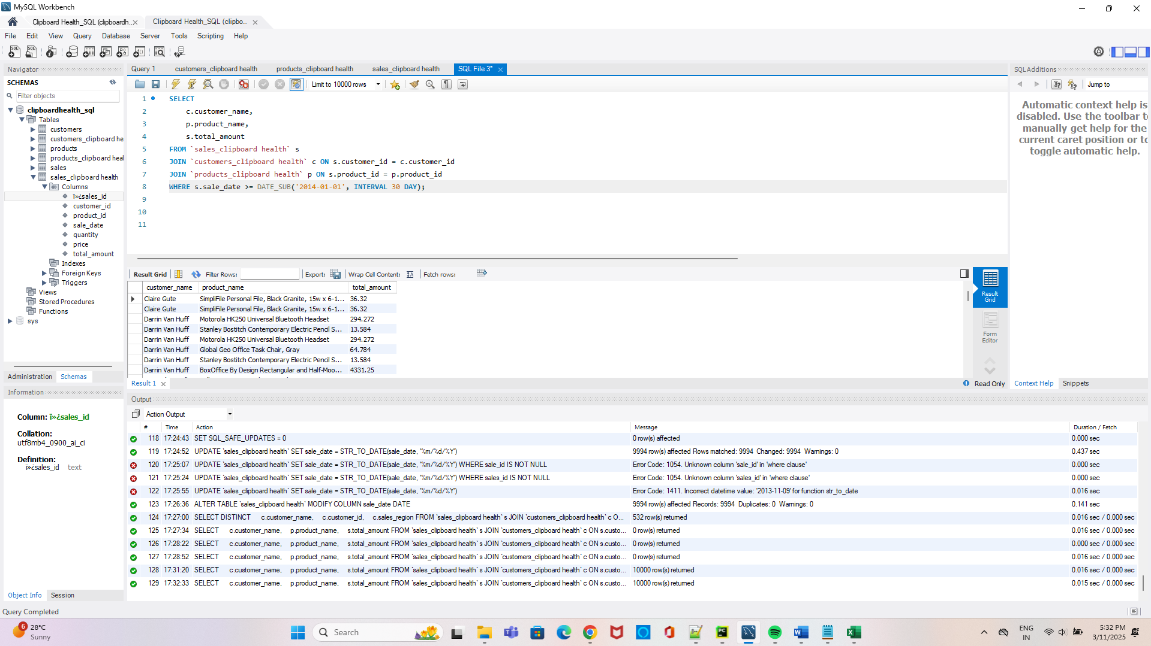

- Write a query to find the total revenue generated by each product category in the last year. The output should include the product category and the total revenue for that category.
Solution:
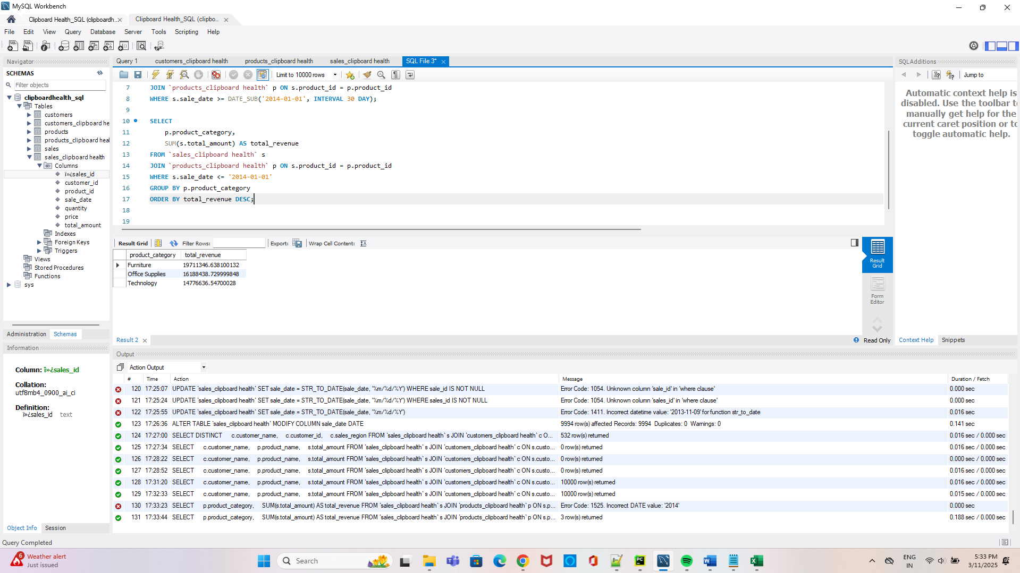
SELECT
p.product_category,
SUM(s.total_amount) AS total_revenue
FROM `sales_clipboard health` s
JOIN `products_clipboard health` p ON s.product_id = p.product_id
WHERE s.sale_date <= '2014-01-01'
GROUP BY p.product_category
ORDER BY total_revenue DESC;

- Write a query to return to all customers who made purchases in 2023 and are located in the "West" region
Solution:
As iam using the data between the years 2011-2014 you will get all the data between them

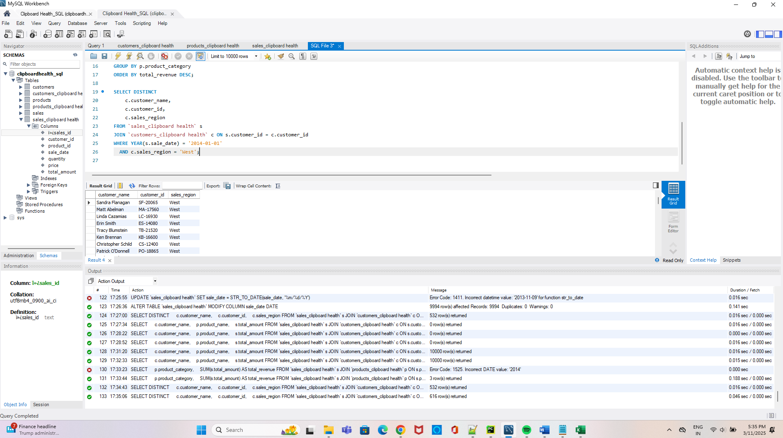

SELECT DISTINCT
c.customer_name,
c.customer_id,
c.sales_region
FROM `sales_clipboard health` s
JOIN `customers_clipboard health` c ON s.customer_id = c.customer_id
WHERE YEAR(s.sale_date) = '2014-01-01'
AND c.sales_region = 'West';
*** If it is for the year 2023
SELECT DISTINCT
c.customer_name,
c.customer_id,
c.sales_region
FROM `sales_clipboard health` s
JOIN `customers_clipboard health` c ON s.customer_id = c.customer_id
WHERE YEAR(s.sale_date) = '2023-01-01'
AND c.sales_region = 'West';

- Write a query to display the total number of sales, total quantity sold, and total revenue for each customer. The result should include the customer_name, total sales, total quantity, and total revenue.
Solution:

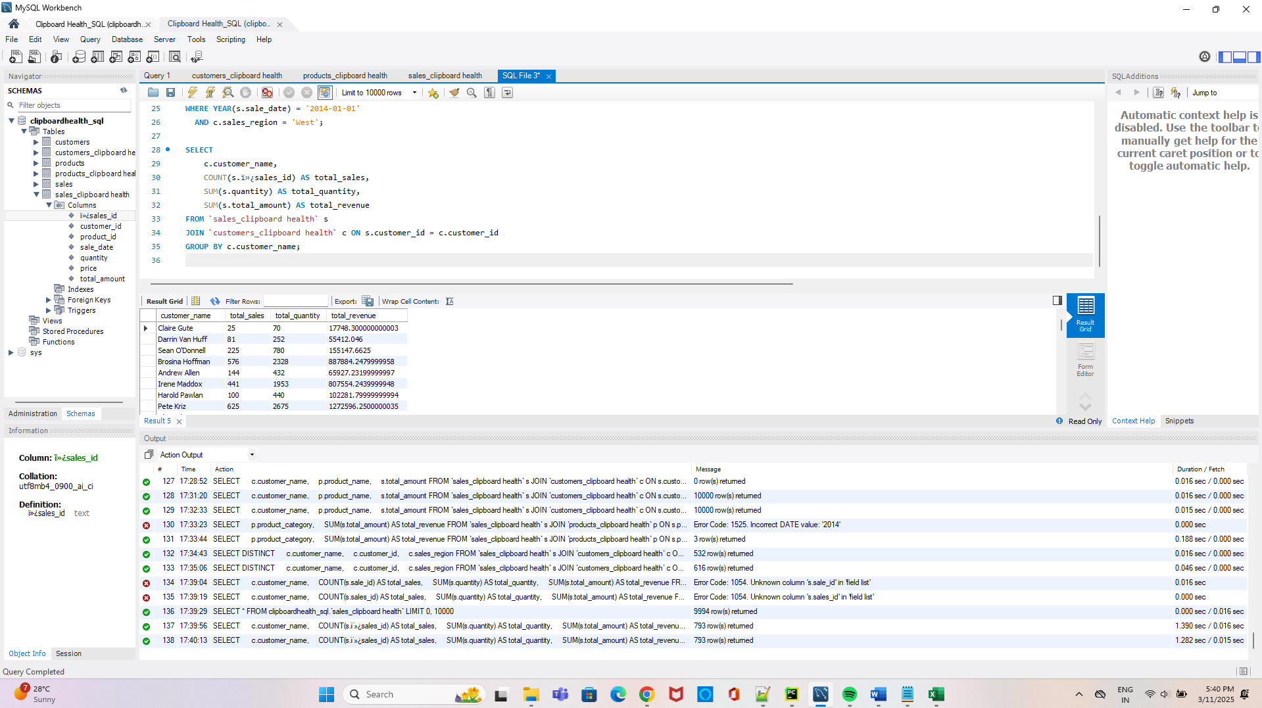

SELECT
c.customer_name,
COUNT(s.ï»¿sales_id) AS total_sales,
SUM(s.quantity) AS total_quantity,
SUM(s.total_amount) AS total_revenue
FROM `sales_clipboard health` s
JOIN `customers_clipboard health` c ON s.customer_id = c.customer_id
GROUP BY c.customer_name;

- Write a query to find the top 3 customers (by total revenue) in the year 2023.
Solution
SELECT
c.customer_name,
SUM(s.total_amount) AS total_revenue
FROM `sales_clipboard health` s
JOIN `customers_clipboard health` c ON s.customer_id = c.customer_id
WHERE YEAR(s.sale_date) BETWEEN 2011 AND 2014
GROUP BY c.customer_name
ORDER BY total_revenue DESC
LIMIT 3;

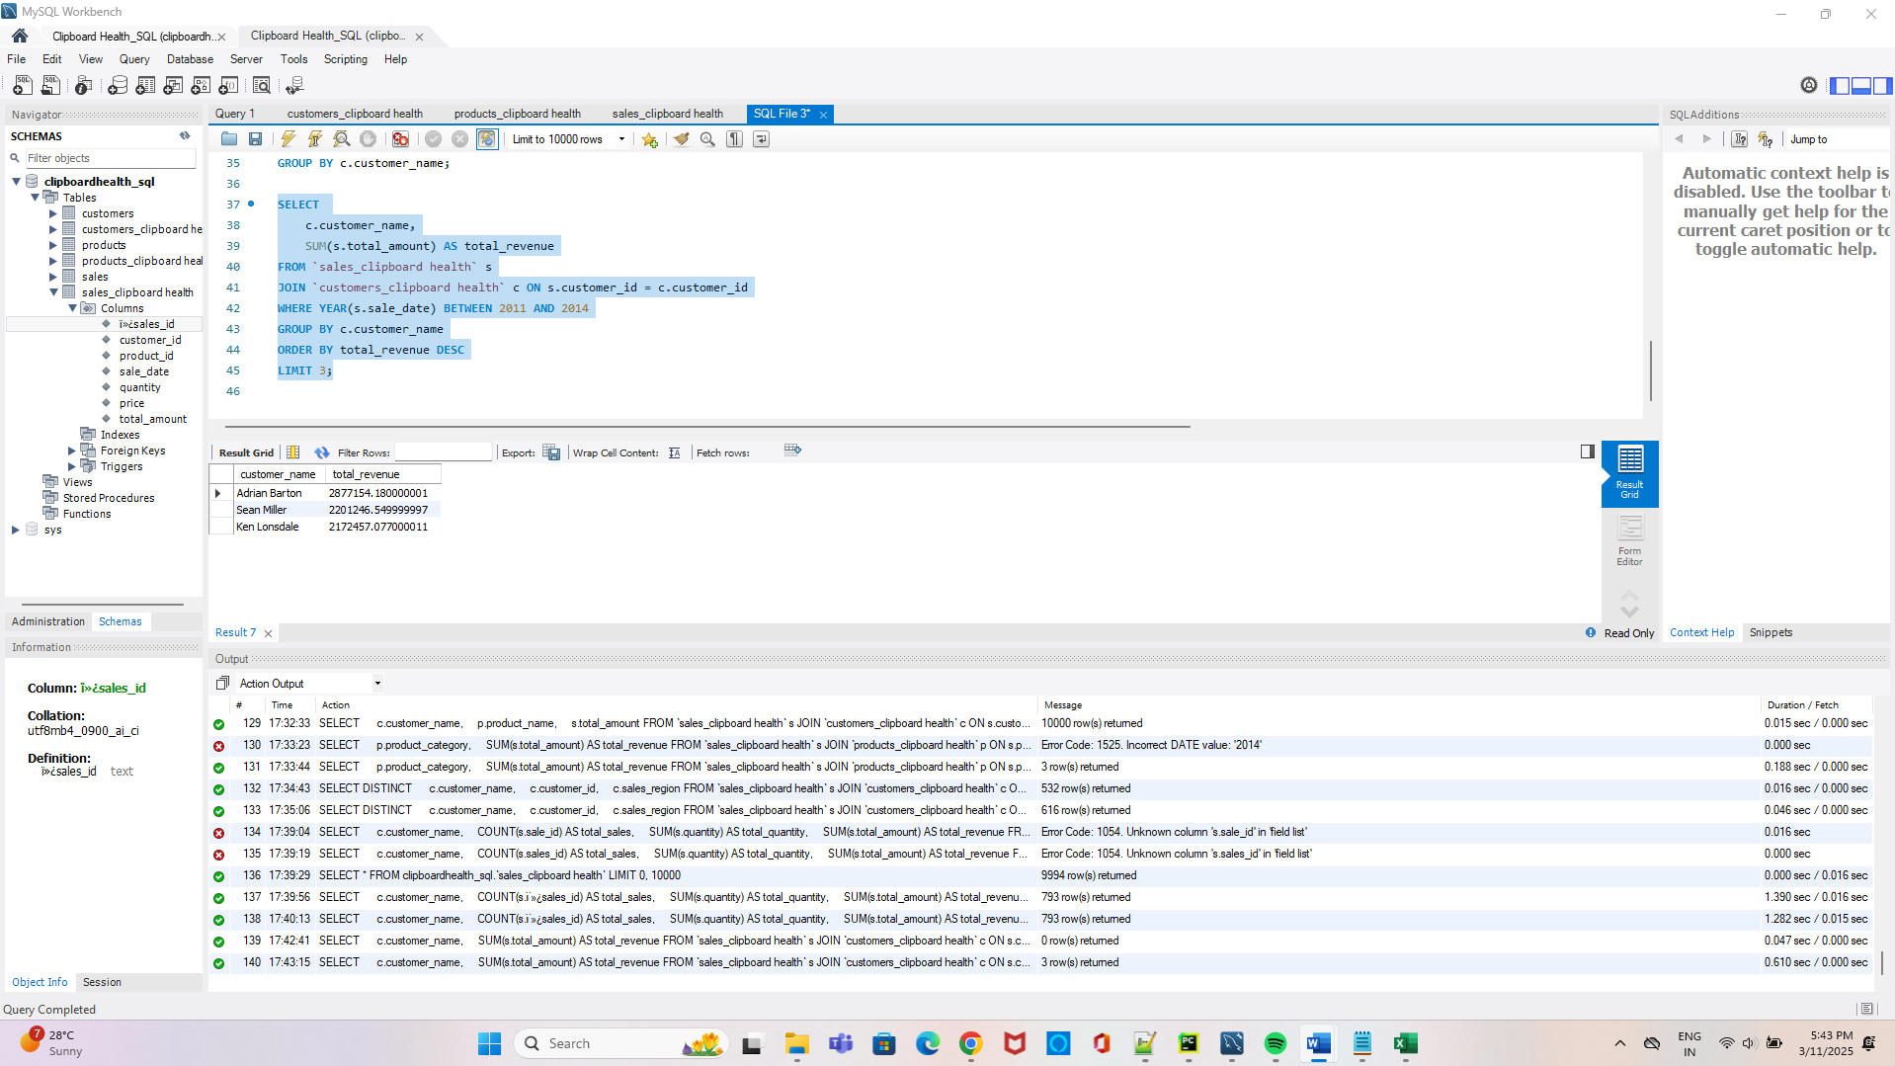
- Write a query to rank products by their total sales quantity in 2023. The result should include the product_name, total quantity sold, and rank.
Solution:
I came up with two solutions for the above question as MYSQL doesn’t not support rank() for version 8
First Method : Rank()

SELECT
p.product_name,
SUM(s.quantity) AS total_quantity_sold,
RANK() OVER (ORDER BY SUM(s.quantity) DESC) AS rank
FROM `sales_clipboard health` s
JOIN `products_clipboard health` p ON s.product_id = p.product_id
WHERE YEAR(s.sale_date) = 2023
GROUP BY p.product_name
ORDER BY rank;
Second Method : Subqueries
SELECT
p.product_name,
total_quantity_sold,
(SELECT COUNT(DISTINCT total_quantity_sold)
FROM (
SELECT SUM(s.quantity) AS total_quantity_sold
FROM `sales_clipboard health` s
JOIN `products_clipboard health` p2 ON s.product_id = p2.product_id
WHERE YEAR(s.sale_date) = 2023
GROUP BY p2.product_name
) AS subquery
WHERE subquery.total_quantity_sold >= products.total_quantity_sold
) AS rn
FROM (
SELECT
p.product_name,
SUM(s.quantity) AS total_quantity_sold
FROM `sales_clipboard health` s
JOIN `products_clipboard health` p ON s.product_id = p.product_id
WHERE YEAR(s.sale_date) = 2023
GROUP BY p.product_name
) AS products
ORDER BY rn;
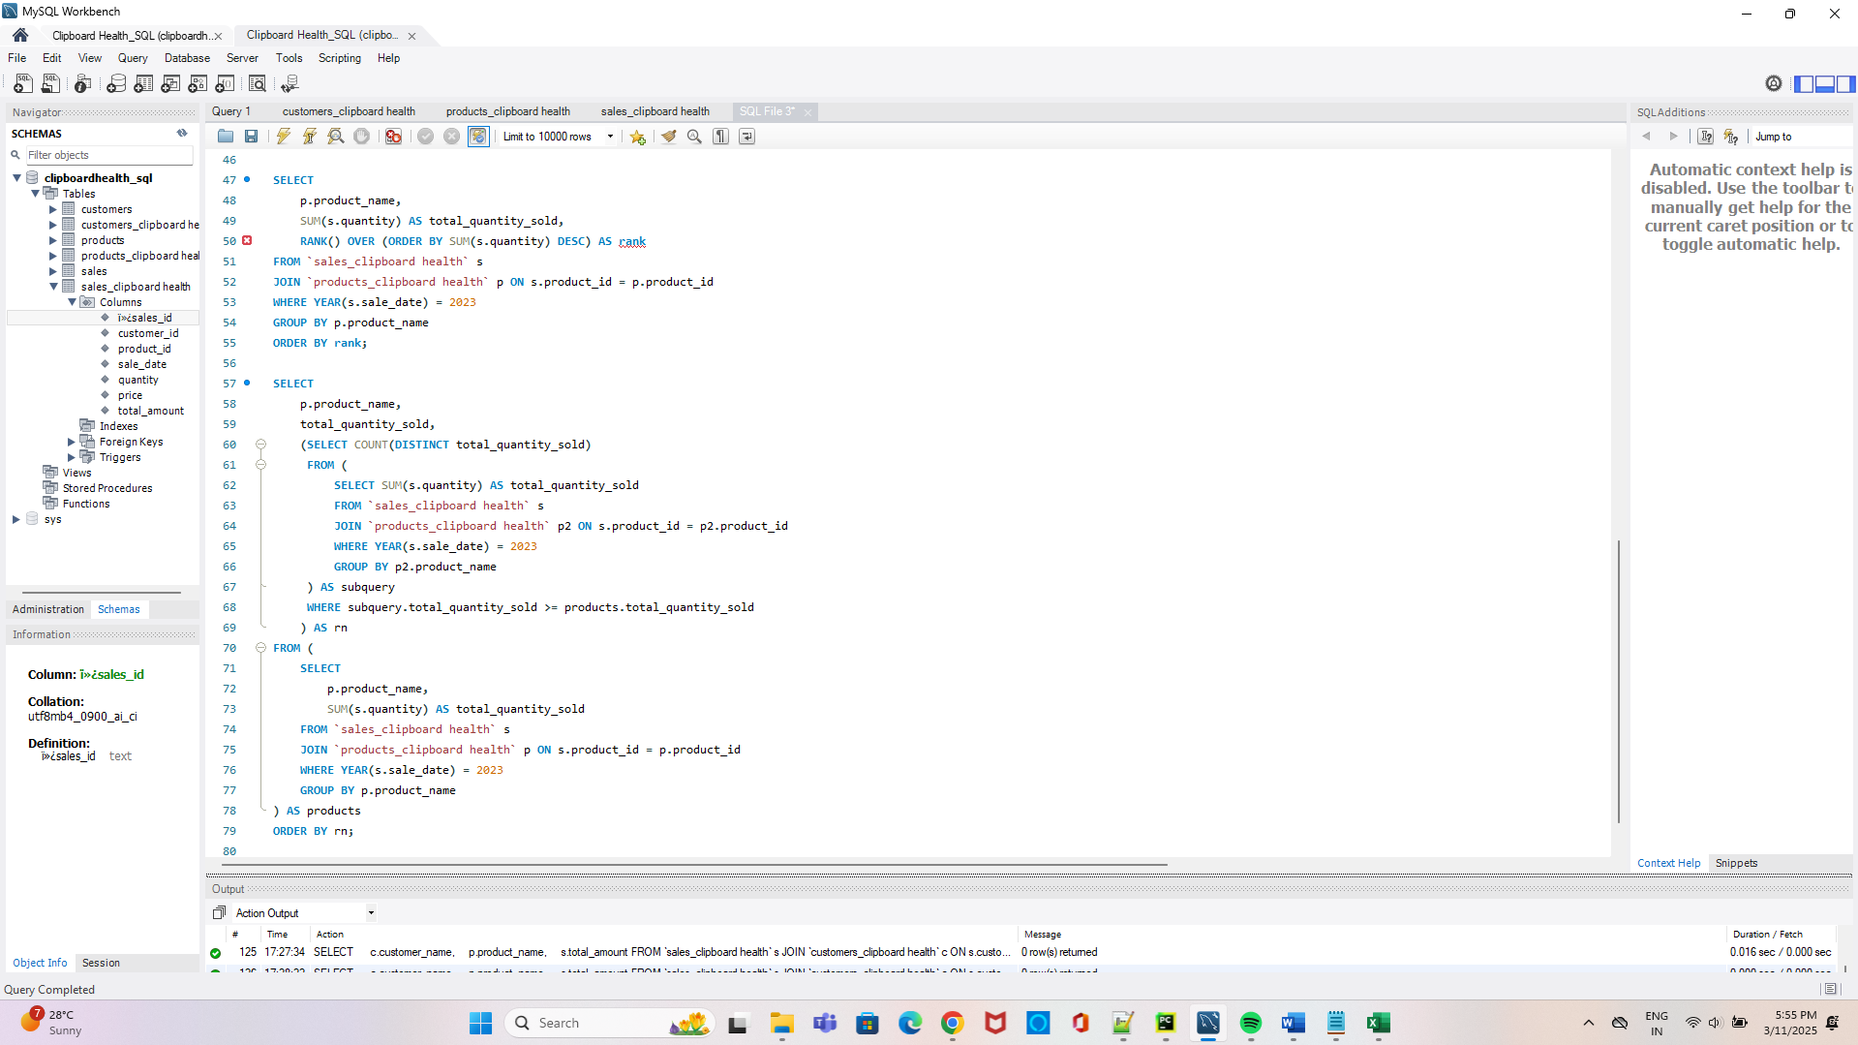
- Write a query that categorizes customers into "New" (if they signed up in the last 6 months) or "Existing" based on their sign_up_date. Include the customer_name, region, and category in the result.
Solution:
SELECT
c.customer_name,
c.sales_region,
CASE
WHEN c.sign_up_date >= CURDATE() - INTERVAL 6 MONTH THEN 'New'
ELSE 'Existing'
END AS category
FROM `customers_clipboard health` c;

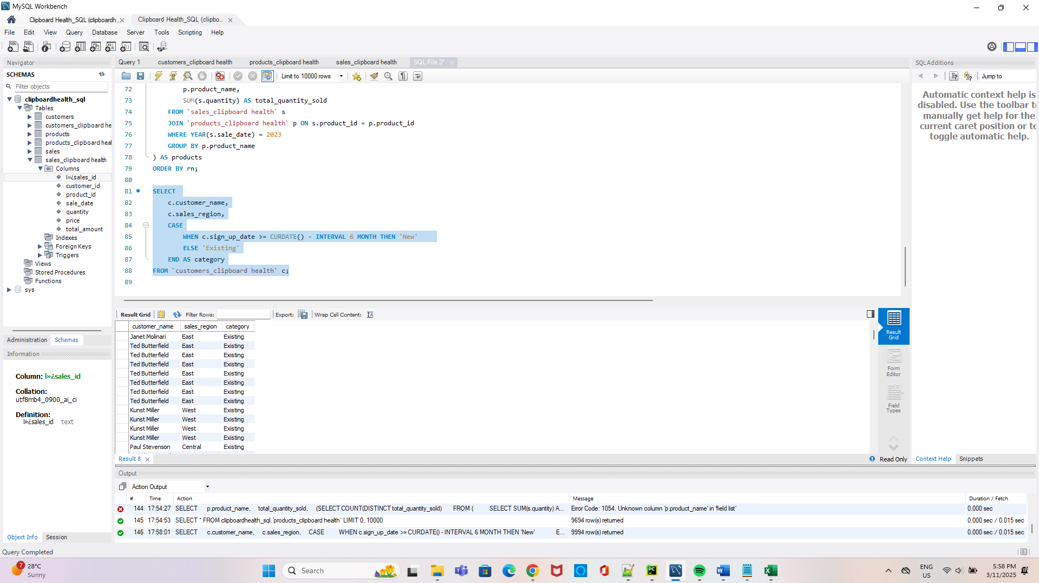
- Write a query to return the month and year along with the total sales for each month for the last 12 months.
Solution :

SELECT
c.customer_name,
c.sales_region,
CASE
WHEN c.sign_up_date >= CURDATE() - INTERVAL 6 MONTH THEN 'New'
ELSE 'Existing'
END AS category
FROM `customers_clipboard health` c;

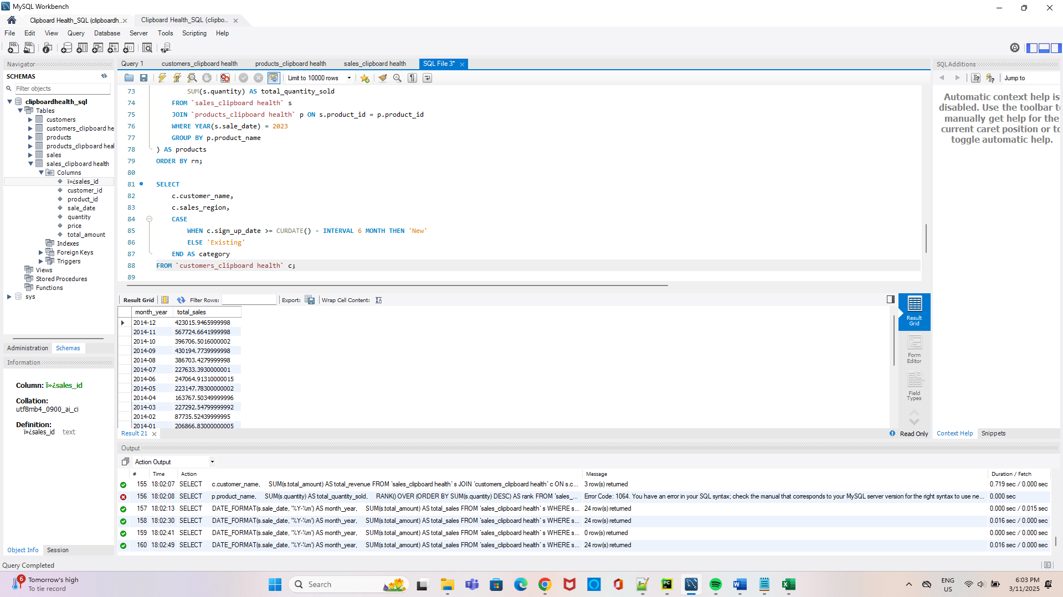
- Write a query to return the product categories that generated more than $50,000 in revenue during the last 6 months.
Solution:
SELECT
p.product_category,
SUM(s.total_amount) AS total_revenue
FROM `sales_clipboard health` s
JOIN `products_clipboard health` p ON s.product_id = p.product_id
WHERE s.sale_date >= DATE_SUB('2014-01-01', INTERVAL 6 MONTH)
GROUP BY p.product_category
HAVING total_revenue > 50000;

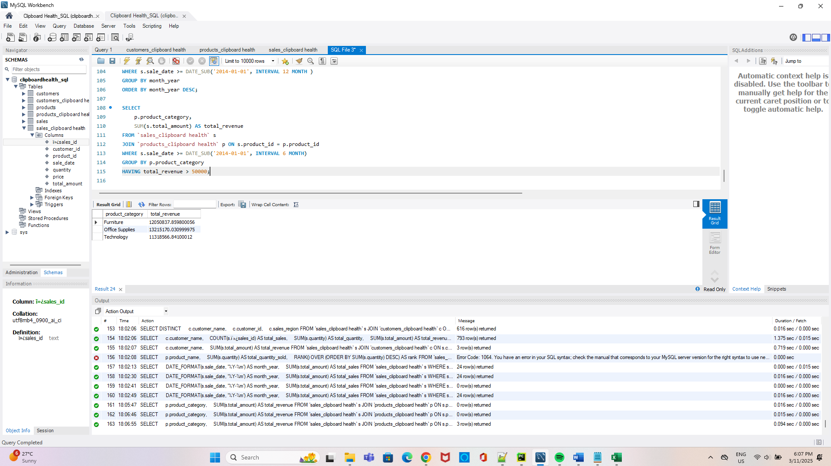
- Write a query to check for any sales where the total_amount doesn’t match the expected value (i.e., quantity * price).

Solution:
SELECT
s.ï»¿sales_id,
s.product_id,
s.quantity,
s.price,
s.total_amount,
(s.quantity * s.price) AS expected_value
FROM `sales_clipboard health` s
WHERE s.total_amount != (s.quantity * s.price);

